# Competitor Research for Multiple File Upload Feature

This is a quick document about competitor research for the Multiple file upload feature in the PDF services. Also, other insights collected during the research is also documented.

## **1. Chat PDF**

*Chatpdf.com*

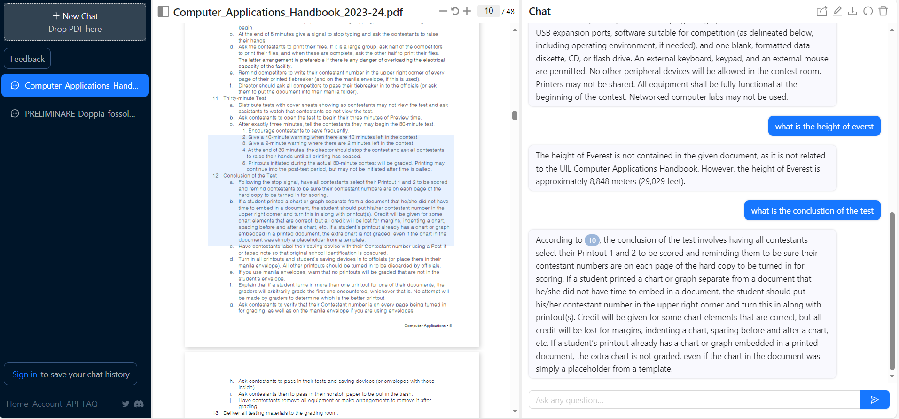

Possible Takeways:

* PDF on the Side
* For source, Highlight on the PDF
* OPTIONS: Reset Chat, Edit Chat Name

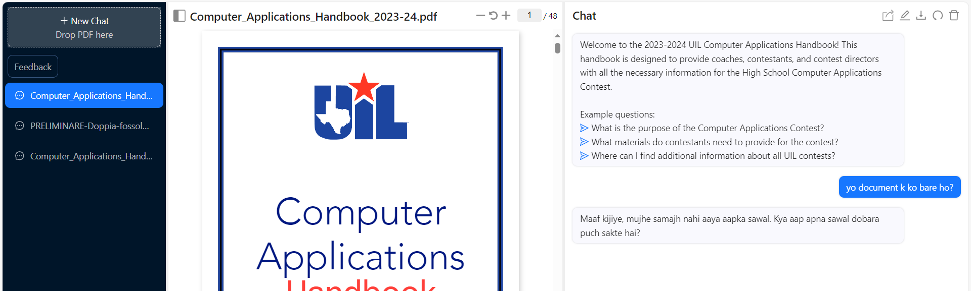

* Language: Can ask questions in Different languages.

## PDF.AI

https://pdf.ai

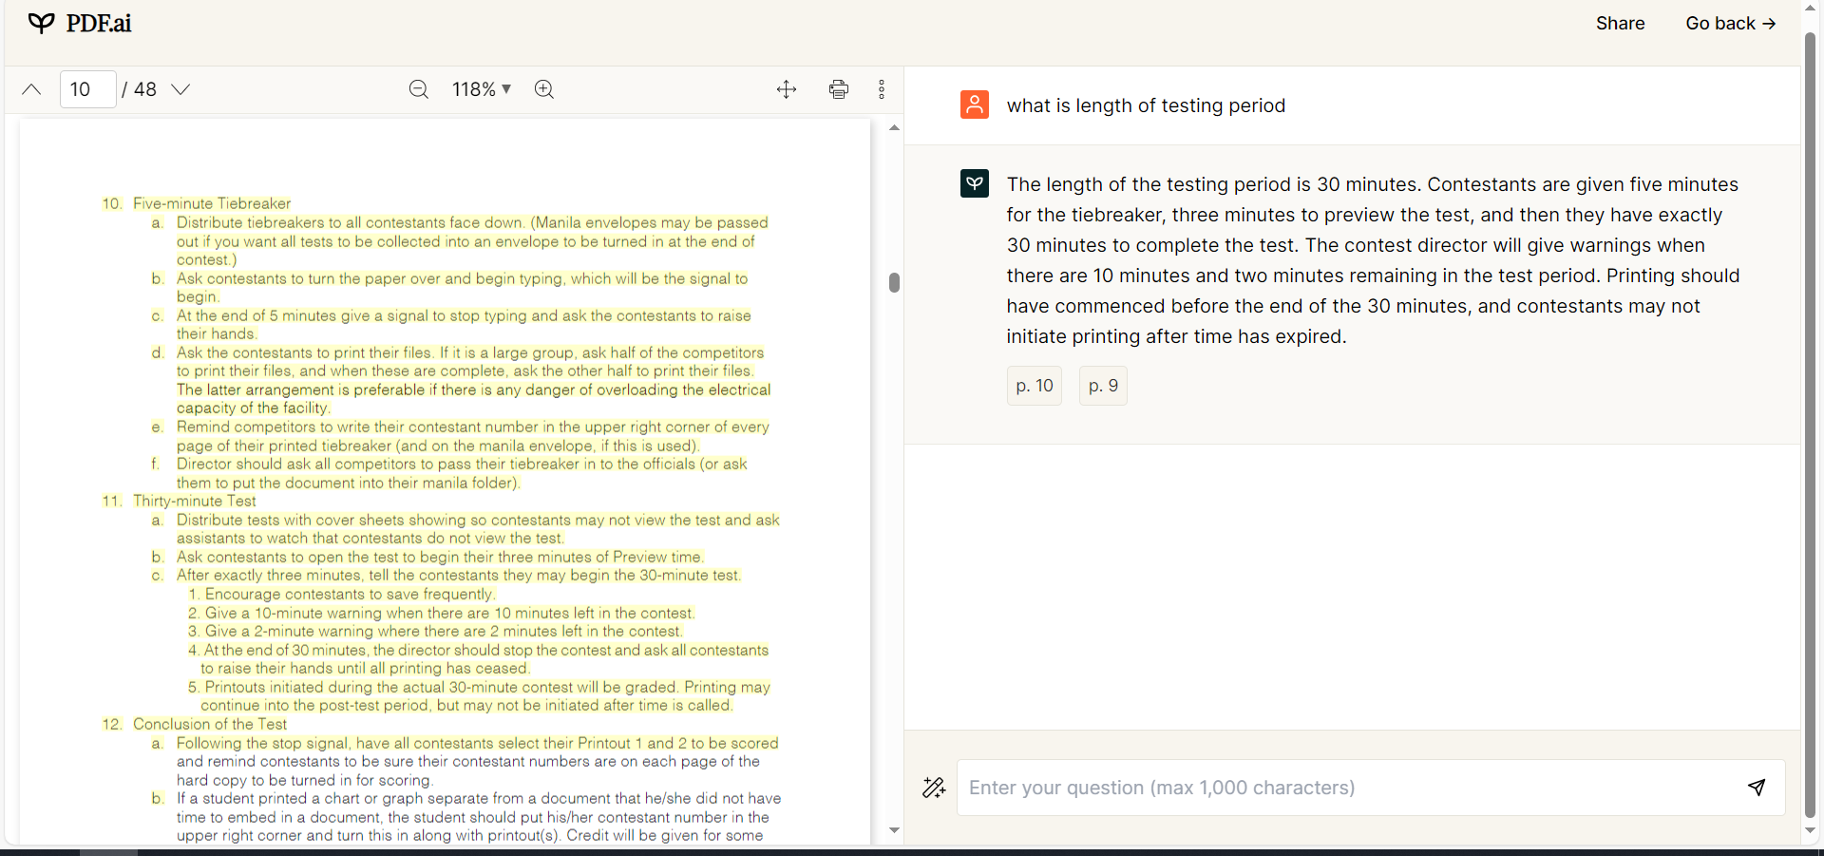

* Highlight style: Instead of Segmenting with a Rectangular box, highlight texts.

>>>>>>>>>>> There are many other competitors with similar feature, UI, design, all are basically same. They allow one session for each PDF, has a PDF viewer on side, and when clicked on source, scrolls to the PDF page or portion.

## **Text Cortex:**

<https://textcortex.com/chatpdf-alternative>

Supports multiple file upload. This supports the multiple file upload, at the beginning, or at session creation time.

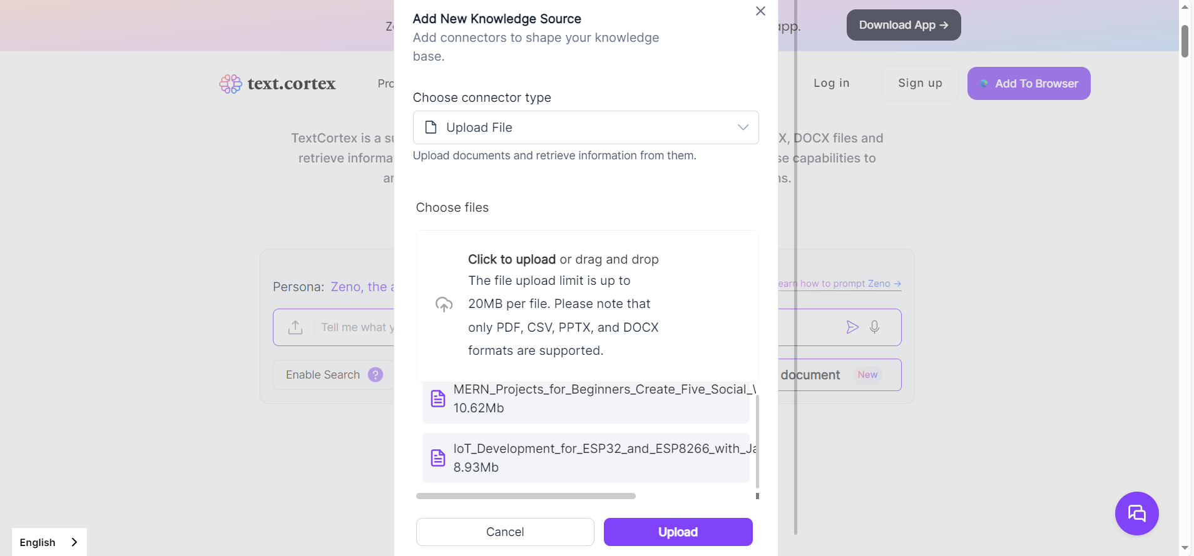

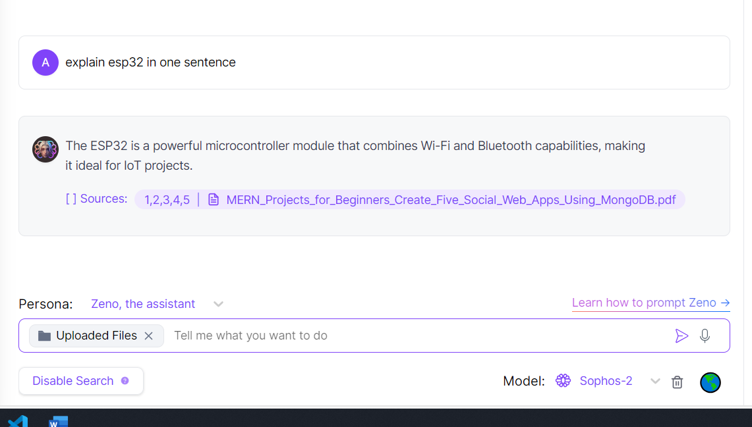

Would allow to chat against uploaded files, but the source is seemingly wrong.

## Custom GPT

A potential competitor with major features, but paid version locked.

<https://customgpt.ai/demo/>

